Possibilities of displaying moving pictures in HTML5 and their use, including limitations compared to Adobe Flash

Bachelor-Thesis

Fabrice, Feugang Kemegni
Matriculation: 671704
Department: Angewandte Informatik B.Sc.
Hochschule Worms

Supervisor:
Prof. Dr. Bernd Ruhland.

Abstract
# Hier erfolgt ein kurzer aber präziser Abriss der Arbeit. Er sollte sich genau an der Arbeit orientieren, die Sachverhalte vollständig enthalten und verständlich sein. Der Abstract sollte aus 100 bis 150 Wörter bestehen, in einem Absatz geschrieben sein und darf weder Bilder noch Literaturzitate verwenden.

Content
Declaration of Authenticity 6
1 Introduction 1
1.1 Problem Statement 1
1.2 Goals 2
1.3 Methodology 2
2 Overview of moving Images 3
2.1 What is an Image 3
2.2 What are moved Images (Videos) 5
2.3 Video Components 7
2.3.1 Codec 7
2.3.2 Video Containers 7
2.4 Reasons for Displaying videos in web pages 8
2.5 Videos in Web pages vs in other Media 9
3 Displaying Videos 10
3.1 Some Video Formats 10
3.1.1 AVI (Audi Video Interleave) 10
3.1.2 Flash Video Format (FLV) 10
3.1.3 WMV (Windows Media Video) 11
3.1.4 MOV (Apple QuickTime Movie) 11
3.1.5 MP4 (Moving Pictures Expert Group 4) 11
3.1.6 ASF (Advanced Systems Format) 12
3.2 Overview of Video Display Methods in Web Pages 12
3.2.1 Embed Tag 13
3.2.2 YouTube 13
3.2.3 Vimeo Embed Code 14
3.2.4 Facebook Video Integrated 15
3.2.5 Adobe Flash 16
3.2.6 Apple QuickTime 17
3.2.7 Windows Media 17
3.2.8 HTML5 18
4 Displaying Videos on web Sites - Adobe flash 20
4.1 What is Adobe Flash 20
4.2 Installation, requirements 20
4.3 A Sample Program 20
4.4 Drawbacks of Adobe Flash 20
4.4.1 Instability 20
4.4.2 Susceptibility to Attacks 20
4.4.3 Outdate 20
5 Introduction and Overview of HTML5 21
5.1 What is HTML5 21
5.2 HTML5 as the alternative for embedding videos 21
5.3 Installation, Setup and Requirements 21
5.4 History and developments 21
5.5 Using HTML to display videos on Webpage 21
5.6 Displaying Videos in web apps HTML5 21
5.7 Sample Program 21
6 Advantages and limitations of displaying videos using HTML5 over Adobe Flash 22
6.1 Limitations of other mechanisms 22
6.2 Advantages of HTML5 22
6.3 Limitations of HTML5 22
7 Trends and Usage Statistics over the Web 23
7.1 Usage Statistics for Adobe Flash 23
7.2 Usage Statistics for HTML 23
8 Conclusion 24
8.1 What Other mechanisms are available 24
8.2 What is the possible development 24
8.3 My preference or suggestion. 24
8.4 Diskussion der Ergebnisse 24
8.5 Ausblick 24
9 List of Figures 25
10 References 26
11 List of Abbreviations 27

Declaration of Authenticity

I hereby declare that all material presented in this document is my own work. I fully and specifically acknowledge wherever adapted from other sources. I understand that if at any time it is shown or proven that I have intentionally misrepresented material present here, any decree or credits awarded to me on the basis of the material may be revoked. I declare that all statements and information contained here is true, correct and accurate to the best of my knowledge and belief.

Ludwigshafen, Winter Semester 2017/18
.....................................................
Feugang Kemegni, Fabrice

Introduction

The tendency for websites to display videos have increased to the extent that event personal websites now display videos. The dominant technique for displaying videos in web sites in the past is the Adobe flash, however it has become relatively unstable and constant victim to software attacks. In the recent years HTML5 has evolved as a new sophisticated tool that can also very well display videos in web applications. The goal of this thesis to demonstrate the possibilities that the new HTML5 offers for displaying videos on websites, and to point some of its limitations for as compared to other popular method particularly the Adobe Flash.
In doing so, Chapter 1 will introduce a brief discussion of what an Image means and what a video means in the domain of computer science, then discus some of the components of a video, followed by the reasons why videos are been embedded in webpages. In chapter 2 I will discuss the most common video formats in use today. Chapter 3 discusses the Adobe flash methods of displaying videos in websites and some of the reasons that encouraged the evolution of alternative methods, chapter 4 is a case Study of Adobe flash player, chapter 5 Introduces HTML5, chapter 6 discusses a case study of how HTML5 displays videos in web pages, chapter 6 Highlights some advantages and imitations of using HTML5 to display videos in webpages as compared to Adobe Flash. Chapter 6 discusses usage statistics over the web, what percentage of applications use HTML5, or Adobe Flash to embed their videos and how the tendency is growing. This chapter is followed by the conclusion chapter where I state my personal analysis on how the tendency is likely going to grow and why.

Problem Statement

The growth of the internet has been accompanied with even more demands to it, one of which is the need to transfer and consume images and videos in web application. Several mechanisms have been developed to display images and videos over web pages one after the other and each to complement the prior one. Today two dominant techniques are used in web applications to display videos, one is the Adobe flash that has been in use for several years now, and the other is the newly evolved HTML5. The tendency is moving from Adobe Flash towards HTML5. A question however arises that is: which possibilities do HTML5 offer to display videos on websites and what are the limitations when compared to Adobe Flash.

Goals

In this thesis, I will demonstrate what possibilities HTML5 offers for displaying videos in websites, and what are the limitations to this technique as compared to other techniques mainly Adobe flash. In doing so, I will first demonstrate the techniques that have been used in the past.

Methodology

Wie möchten Sie ihr Ziel erreichen. Aus der Vorgehensweise lässt sich dann eine erste grobe Gliederung der Arbeit ableiten.

Overview of moving Images

This chapter discusses some brief definitions about the structure and main components of a video which is an image. The first section discusses what an image is and what it is composed of, the second section build on what have been learn about an image to describe what a video is and the characteristics of a video. The last section of this chapter discusses the reasons why videos are being placed in websites.

What is an Image

The definition of an image varies deeply across domains and fields of studies. In computing and computer science an image is a two dimensional signal or a mathematical function f(x , y) where x and y are the horizontal and vertical coordinates of pixels. The value of f(x , y) at any point gives the pixel value at that point of an image. The pixel carries the value of a Colour, intensity as well as some other image information. The figure below explains the relationship between an image and its pixels.

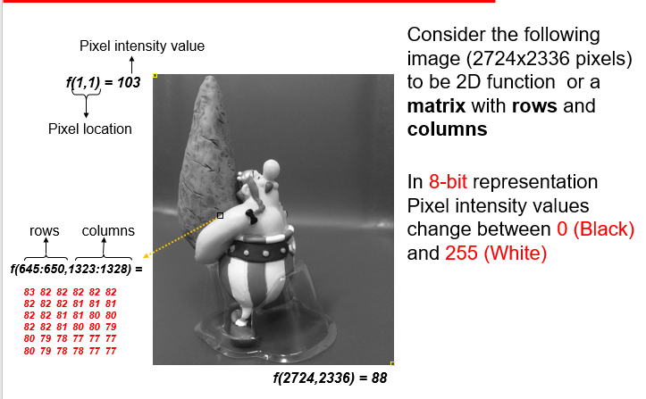
Figure 1 : Digital Image (2740x2336 Pixels)
This a 2750x2336 Image viewed as a 2D function. The little yellow box at the top left of the image represents a pixel at coordinate f(1,1) and the value 103 which represents a grayscale or colour. In this example the pixels are 8-bit, which means the pixel values range between 0 to 255 (decimal representation of 8-bit range).

A detailed definition of pixel in this work is out of scope, readers should simply consider a pixel as the basic component of an image and that an image is a collection of pixels that build a visible perceptible object.
The technical aspect of an image is not required for this work. For simplicity, an image is defined here as graphical object that is displayed over a display medium. This definition does not embody dynamic images like gifs, but only static 2-dimensional images.

What are moved Images (Videos)

A moving image or to say a video in technical terms is a 3-dimensional image. As defined above, a 2-dimensional image is a function with two variables, x and y that map a pixel value over a given domain. Once an image has been defined in such terms, a video is an image with an additional third dimension which is time. A video is basically a collection of superimposed images that are displayed one at the time and one after the other in a specific order and time lap.
A video could be understood as a stack of several images together and each image is marked with a timestamp in the time interval, such that each timestamp corresponds to an image in the stack. Supposing a stack of 60 images, and a time interval of 60 seconds, each image in the stack is marked with a unique time as second in this interval. Placing these stacked images in a device that will display each image of the stack at the specified timestamp. Such a device is called a video player. The result of displaying these images at the stated timestamp is what we see as a video. Hence requesting a particular image to the playing device by providing its timestamp is the equivalent of jumping to a time interval in the video just like what we do when we fast-forward a video in YouTube or VLC player. Figure 2 below illustrate a basic video consisting of stacked images.
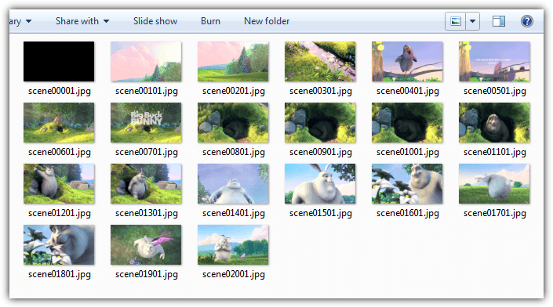
Figure 2: Video Frames
The 21 Pictures/Images in the figure will constitute frames when grouped together to form a video.

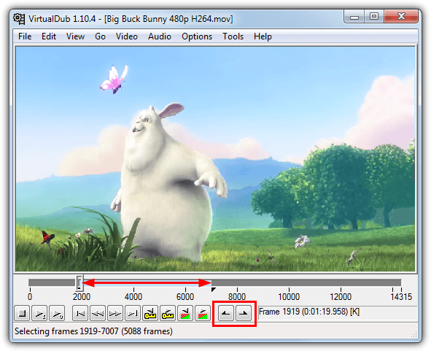
Figure 3: Frame Clipping
The Figure attempts to illustrate how the Images/frames are stacked together to produce a video.

Each image in such a stack/video is called a frame and the interval or time lap in most videos is between 24-30 images per second, where the term frame per second (FPS). Video files simply store all frames together and a video player plays them in order.
With such a brief introduction and description of what images and videos are, it is now possible to illustrate the classification that exist within images.

Video Components

Videos are stored in a compressed form to reduce the amount of space they may use. A video file typically consists of a container consisting of a - video data in video coding format and audio data in audio coding format. The container format can also contain synchronization information, subtitles, and metadata such as title. A standardized (or in some cases de facto standard) video file type such as .webm is a profile specified by a restriction on which container format and which video and audio compression formats are allowed.
There are hundreds of types of videos and video formats and each type/format serves a purpose better than the others. It is to be noted that a video can be converted from one format into another format using algorithms.

Codec

A codec is a computer algorithm that encodes/decodes or compresses/decompresses digital stream data like videos or audios, it also interprets the data stream (e.g. video/audio) and determines how best to play the video on the output medium. Electronic devices capable of displaying videos all come with some preinstalled codecs, computers for example come with some codecs and users are mostly required to download install more codecs, this is often the case when the computer encounters errors like “file extension not supported” or “cannot play media”.

Video Containers

A video container is a bundle of media files, often consisting of a video and an audio codecs and sometimes also information like subtitles. Containers allows user to choose one codec for the video and another codec for the audio.

Reasons for Displaying videos in web pages

There are hundred reasons why videos are being displayed on websites, below are some of these reasons:
Shopping websites must display images and videos on their websites so as to show to the potential customers what their products and services look like. An example here is in the vacation industry, where videos of beaches, hotels mountains, cruising tours must be shown to users to motivate them into committing to carry purchase.
If not displaying an unpurchased product, companies may also need to illustrate how the customers should or could use their purchased products. These include videos of installation guides, after sale supports where a video featuring a trained personal demonstrating how to assemble a chair, bicycle, a tent or any product that could have been purchased in a disassembled state and requiring the customer be assembled the product themselves.
The academics also make use of videos in their web pages. This could be videos for tutorials, videos of welcome, new Students orientation, visitor’s orientation etc. Thus, requiring videos to be embedded in their websites.
Television channels also have some branches that are online and requiring live broadcasts or archives or shows. These either require streaming of videos either live streaming or not. Viewers have the opportunity to choose among viewing their favourite shows live on Television or on web browser. This increasing the need to display videos on web pages.
Video sharing websites make extensive use of videos in their websites and these videos constitute more than 80% of the content of their websites. YouTube, Netflix, even Facebook make extensive use of videos in their web application.

As stated before, the list of reasons why websites may contain videos is exhaustive, I have just provided some common reasons why videos may be found in a website.

Videos in Web pages vs in other Media

Displaying videos in a website differs from displaying videos in other media in several ways. One of the main difference is that a video in a website requires bandwidth and buffers. A website requires the video to be buffered, ie a certain percentage of the video must be loaded before the video starts playing. This in comparison to a video played on the computer from a video player does not require the video to be buffered, the video is instantly played.
Refreshing the browser page makes the video restart from the beginning, and the amount of already buffered video is lost. The video restarts each time the connection to the internet is lost. This means if you are watching a video over a web browser, then the internet goes off and on, the video needs to restart as the browser needs to re-establish a connection with the website.
Low bandwidth leads to poor viewing quality as the video will frequently freeze while it is being buffered, this may lead to inconveniences and bad user experience compared to a video been viewed from a video player program on the computer.
Displaying a video on a website requires the dimensions of the video to be customized. Not all the videos are being embedded the same way in to a website. The videos width, height, scale and other parameters need to be edited, otherwise the video will be either cropped, hidden or wrongly scaled. In comparison to playing a video over a video player in the computer or television, where no additional setting is required for videos of different sizes.

These differences highlight the attention required for displaying videos in websites, which make it a little more difficult.
In the next chapter, I discuss some video formats used over the internet and how the differ among each other and some of the methods used to display videos on webpages.

Displaying Videos

In the previous chapter, I defined what a video is in the context of computing, I also highlighted the structure of a video and finally I gave some reasons why videos are displayed in websites. In this chapter I will discuss some of the most common video formats in use in web applications, some methods used in the past by websites to display videos, and finally which of these methods have evolved and which are no longer in use today.

Some Video Formats

As previously Introduced, there are dozens of video formats, each with their characteristics, abilities and each being appropriate for a specific purpose. Below are 6 of the most commonly encountered videos formats in computing. This list does not order nor sort the most important formats, instead lists the most frequently used video formats for example in websites, or computers. This does not account other embedded devices like digital camera because they don’t use web browser.

AVI (Audi Video Interleave)

Developed and published by Microsoft in 1992 AVI is one of the oldest video formats. Due to its simple architecture, AVI files are able to run on several architectures like Windows, Macintosh, Linux, and also supported by popular web browsers. AVI files are opened with: Microsoft Windows Media Player, Apple QuickTime Player and VideoLAN VLC media player.

Flash Video Format (FLV)

These are files that are encoded by the Adobe Flash Software, can be played via the Adobe Flash Player, web browser plugins and on several third-party programs. Since virtually every browser has the Adobe Flash plugin installed, it has become the most common online video viewing platform on the web. Almost all video sharing sites including YouTube stream videos in Flash. The Flash Video format is also what many video-sharing sites convert videos to, from formats that were uploaded by their users in something other than Flash. This is because videos in the FLV format remain in high quality even after compression to a smaller file size, which means that the videos on the Web load quickly and won’t spend a lot of time using up bandwidth. Some notable users of the Flash Video are YouTube, Yahoo! Video, VEVO, Hulu and Myspace among many others.

WMV (Windows Media Video)

Developed by Microsoft, it was originally designed for web streaming applications, but can now cater to more specialized content. WMV files are the tiniest video files over the Web, as their file size decreases significantly after compression, resulting to poor video quality. However, this small file sized format allows users to upload and share their videos through the e-mail system.
Being a Microsoft software, the Windows Media Player is the main application that is used to play WMV files on all Microsoft’s Windows operating systems, but there are also WMV players available for free for the Macintosh operating system.

MOV (Apple QuickTime Movie)

Developed by Apple. Inc, the QuickTime file format is a popular type of video sharing and viewing format amongst Macintosh users. It is often used on the Web, and for saving movie and video files. There is a free version of the QuickTime Player available for the Windows Operating System among many other players. MOV files are of high quality and are usually big in file size.

MP4 (Moving Pictures Expert Group 4)

MP4 is an abbreviated term for MPEG-4 Part 14, a standard developed by the Motion Pictures Expert Group who was responsible for setting industry standards regarding digital audio and video, and is commonly used for sharing video files on the Web. This video format uses separate compression for audio and video. The video track is compressed with MPEG-4 or H.264 video encoding, while the audio track is compressed using AAC compression. It is also a great file sharing format for the Web as MP4 file sizes are relatively small but the quality remains high even after compression. Due to its compatibility with both online and mobile browsers and the fact that it is supported by the new HTML5, MP4 standard is also becoming more popular than FLV for online video sharing, as it compatible

ASF (Advanced Systems Format)

Another offering from Microsoft, the ASF container normally houses files compressed with Microsoft’s WMA (Windows Media Audio) and WMV codec. Just to confuse the matter further, the files are usually given the .wmv or .wma suffix and not the expected .asf. A form of copy protection is offered with this container through Digital Rights Management (DRM). This file format opens with: VideoLAN VLC media player and Microsoft Windows Media Player.
These 6 Video file formats listed above is not the complete list of all video file formats available, instead a list the most frequently encountered formats for computer users, there are many more formats available, but listing all of them is out of scope for this thesis. The idea of listing these is just to familiarize the reader with some terms that will reoccur in future chapters.

Overview of Video Display Methods in Web Pages

This section describes some methods used to display videos throughout websites. Each way you embed your video will depend on the video format that you want to display.
Some of these formats are discussed in the previous section. The desired format then requires the use of a video player that can play the video format. The video player is easily downloadable over the Internet. Below are the steps to embed your videos into your website.

Embed Tag

This method is frequently used for short videos (about 10 seconds long), and when the bandwidth and buffering times is no issue. This is the traditional method. You just need to use the html tag “embed” and link the source of the video to the tag. The browser will handle the rest. The code below illustrate how to embed a video using the html embed tag.
<embed src="my-mp4.mp4"
width="500"
height="auto"
controller="true">

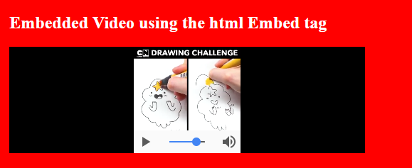
Figure 4: Displaying a Video using html embed tag

YouTube

YouTube is often used to embed videos when the normal embed tag takes too long to load the video. This method is fast and free, but requires that the video be first uploaded to YouTube, then referencing the id of the uploaded YouTube video on your website. To use this method, you need to create a YouTube account, then upload the video to this account, YouTube automatically generates the embed Tag that you need to insert in your website code.
The trade off with this method is that you lose all control over your video, as anyone else on youtube can freely download and also embed your video to their site.
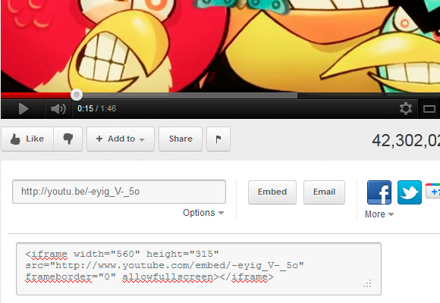
Figure 5: Embed a Youtube Video
Once you have uploaded a video to youtube, youtube offers the possibility to embed the video to your website, click on the “embed” button, the link appears below, paste the content of the link into your website code.

Vimeo Embed Code

https://vimeo.com
Vimeo is YouTube’s main rival, especially in the area of video embedment options. Vimeo videos are also viewed by thousands of web users and can be easily integrated into other websites or blogs. Vimeo player is very handsome and streamlined. The blue “Embed” button in the upper right of the video leads to a dialog box with the embedding options. Basic account holders are allowed to customize player size, text colors and add other elements, while Vimeo Plus members enjoy the complete control over the player, including options to choose what happens next and where the video can appear.

Facebook Video Integrated

Facebook doesn’t officially provide any video embedding options, still if your video is available only on Facebook, there is a workaround. Each video on Facebook has an id, to view this right click on the video and select show video URL, copy the url which shows in the URL, e.g. http://www.facebook.com/video/video.php?v=2894326448598 Copy this link to your website code.
The code snippets below show how to embed a Facebook into a website, and the figure following the code snippet shows how the embedded video is displayed on the browser.
<object width="560" height="315" >
<param name="allowfullscreen" value="true" />
<param name="allowscriptaccess" value="always" />
<param name="movie" value="https://www.facebook.com/plugins/video.php?href=https%3A%2F%2Fwww.facebook.com%2FSarahRayTV%2Fvideos%2F1263433353761368%2F" />
<embed src="https://www.facebook.com/plugins/video.php?href=https%3A%2F%2Fwww.facebook.com%2FSarahRayTV%2Fvideos%2F1263433353761368%2F"
type="application/x-shockwave-flash"
allowscriptaccess="always"
allowfullscreen="true"
width="500"
height="auto">
</embed>
</object>

Below is another way to embed the same Facebook video to the webpage.

<iframe src="https://www.facebook.com/plugins/video.php?href=https%3A%2F%2Fwww.facebook.com%2FSarahRayTV%2Fvideos%2F1263433353761368%2F"
width="560"
height="315"
style="border:none;overflow:hidden"
scrolling="no"
frameborder="0"
allowTransparency="true"
allowFullScreen="true">
</iframe>

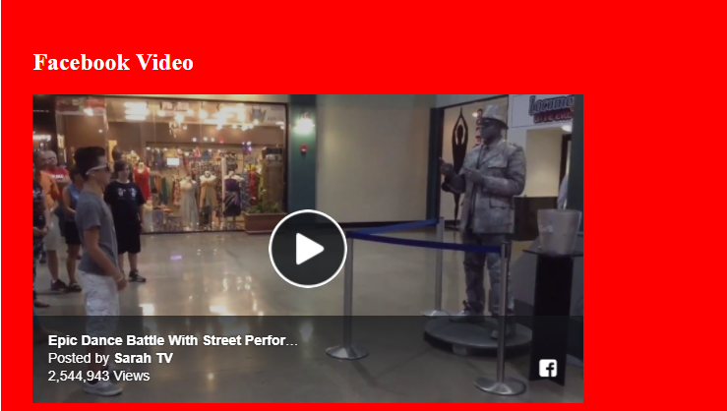
Figure 6: Embeding a Facebook Video in to the website

You can then put the code on any web pages and the Facebook video will play just like any other Flash video. You can optionally change the player size, add more parameters like auto play or loop.

Adobe Flash

To use the media Player, you first need to download the Windows Media Player which is free to download under google http://code.google.com/p/youplayer/downloads/detail?name=mediaplayer.swf After downloading the player, place it in to your website folder or server. Include the embed code in your website see the figure below.
A Detailed illustration for displaying videos on a webpage using the Adobe Flash Method is presented in the next chapter.

Apple QuickTime

This requires the Apple QuickTime to be installed on the browser. The figure below describes how to embed a video to use flash player. Additional instructions how to install or uninstall this plugin can be found here.
Below is a code snippet of how to embed a video to be played by the Apple QuickTime Player. The Browser output is displayed in the figure following the code snippet.
<object classid="clsid:02BF25D5-XXXXXXXXXXXXXXXXX"
codebase="http://apple.com/qtactivex/qtplugin.cab"
width="560"
height="315">
<param name="src" value="my-mp4.mp4">
<param name="autoplay" value="true">
<embed src="my-mp4.mp4"
type="image/x-macpaint"
pluginpage="http://www.apple.com/quicktime/download"
width="560"
height="316"
autoplay="true">
</embed>
</object>

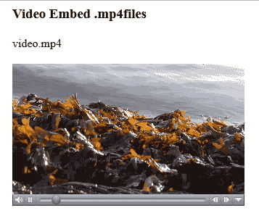
Figure 7: Browser output for a playing a video using Apple's Quicktime Player

Windows Media

Requires Windows Media Player installed on the web browser.
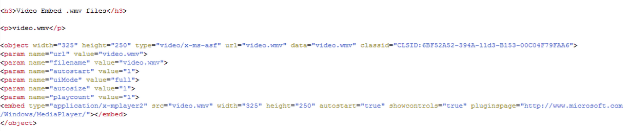
The browser’s output is shown in the figure below.
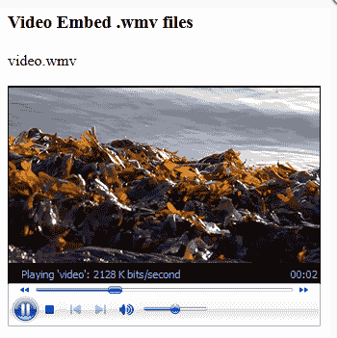
Figure 8: Displaying a Video using the Windows Media Player Plugin

HTML5

HTML5 is one of the most straightforward new techniques of video embedment. The new <video> tag in HTML5 mark-up allows web developers to add videos into a web page without any special plugins. To make the most of HTML5 video, you have to prepare your video in three variants – H.264, Theora OGG and WebM, since different web browser support this or that video codec for the new HTML5 standard. The sample code for HTML5 video looks like this: https://www.w3schools.com/html/html5_video.asp. Below are the code snippet and the browser output when embedding a video using the HTML5 method.
<video width="500" controls>
<source src="mov_bbb.mp4" type="video/ogg">
<source src="my-mp4.mp4" type="video/mp4">
Your browser does not support HTML5 video.
</video>

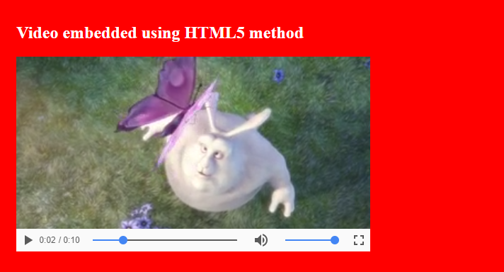
Figure 9: Displaying a Video using the HTML5 method

There are several other Methods for displaying videos in websites, most of which are web based and provide step by step instructions to even novice users on how to embed a video to their website. Some of these methods include:
https://oembed.com/
http://www.cocoonsoftware.com/en/
http://www.freevideocoding.com/
http://videolightbox.com/
http://easyhtml5video.com/

Displaying Videos on web Sites - Adobe flash

As stated in the problem statement and goal of this thesis, Adobe Flash and HTML5 are the point of interest. The previous chapters have already provided some foundations on which to build upon. It is already clear what a video is, types and formats of videos, why and how to embed a video in a website.
In this chapter I provide a detailed discussion on Adobe Flash. In the first section I describe Adobe Flash player and how to use it, in the second section I provide a sample program that illustrate how adobe flash player displays a video in the website.

Adobe Flash Player

It is a video player plugin for web browsers. In most web browsers it is built in, so users do not need to install or activate it. It may be downloaded here.

Installation, requirements

A Sample Program

Drawbacks of Adobe Flash

Instability

Susceptibility to Attacks

Outdate

Introduction and Overview of HTML5

What is HTML5

HTML5 as the alternative for embedding videos

Installation, Setup and Requirements

History and developments

Using HTML to display videos on Webpage

Displaying Videos in web apps HTML5

Sample Program

Advantages and limitations of displaying videos using HTML5 over Adobe Flash

Limitations of other mechanisms

Advantages of HTML5

Limitations of HTML5

Trends and Usage Statistics over the Web

Usage Statistics for Adobe Flash
This is because videos in the FLV format remain in high quality even after compression to a smaller file size, which means that the videos on the Web load quickly and won’t spend a lot of time using up bandwidth. Some notable users of the Flash Video are YouTube, Yahoo! Video, VEVO, Hulu and Myspace among many others.
https://askubuntu.com/questions/310312/how-to-configure-geany-to-wrap-lines

Usage Statistics for HTML

Conclusion
In diesem Kapitel werden die Ergebnisse der Arbeit diskutiert und ein Ausblick auf interessante Weiterentwicklungsmöglichkeiten gegeben.

What Other mechanisms are available

What is the possible development

My preference or suggestion.

Diskussion der Ergebnisse
Stellen Sie die Ergebnisse der Arbeit noch einmal präzise zusammen und beantworten Sie die Frage: „Warum ist meine Lösung eine gute Lösung?“

Ausblick
Auf welche Probleme sind Sie im Laufe der Umsetzung gestoßen, die in einer weiterführenden Arbeit untersucht werden könnten? Welche Ansätze zur weiteren Optimierung der Lösung sind ggf. noch möglich?

List of Figures

References
Quellen bitte in alphabetischer Reihenfolge und ohne Trennung nach Quellenarten. Nachfolgend einige Beispiele für verschiedene Quellen:

Monographien:
Mathes, H. D. (1978): Produktentscheidungen in komplexen Kaufsituationen, Diss. Siegen.
Mertens, P./Bodendorf, F./König, W./Picot, A./Schumann, M. (1998): Grundzüge der Wirtschaftsinformatik, 5. Aufl., Berlin et al.
Skiera, B. (1999): Mengenbezogene Preisdifferenzierung bei Dienstleistungen, Wiesbaden.
Beiträge in Sammelwerken:
Huhns, M. N./Stephens, L. M. (1999): Multiagent Systems and Societies of Agents, in: Weiss, G. (ed.): Multiagent Systems: A Modern Approach to Distributed Artificial Intelligence, Cambridge et al., pp. 79-120.
Kirn, S./Petsch, M. (2001): DFG-Schwerpunktprogramm (1083) “Intelligente Softwareagenten und betriebliche Anwendungsszenarien”, in: Sebastian, H.-J./Grünert, T. (Hrsg.): Logistik Management – Supply Chain Management und e-Business, Stuttgart, Leipzig, Wiesbaden, S. 389-400.
Zeitschriftenaufsätze:
Davis, R./Smith, R. G. (1983): Negotiation as a Metaphor for Distributed Problem Solving, in: Artificial Intelligence, Vol. 20, No. 1, pp. 63-109.
Grolik, S./Stockheim, T./Wendt, O./Albayrak, S./Fricke, S. (2001): Dispositive Supply-Web-Koordination durch Multiagentensysteme, in: Wirtschaftsinformatik, Jg. 43, Nr. 2, S. 143-155.
Zeitungsbeiträge:
Willgerodt, H. (1972): Strategie gegen die Marktwirtschaft, in: Frankfurter Allgemeine Zeitung, Nr. 269, 18. Nov. 1972, S. 19.
Internetquellen:
FIPA (2002): FIPA Contract Net Interaction Protocol Specification, Foundation for Intelligent Physical Agents, http://www.fipa.org/specs/fipa00029/XC00029G.pdf (25.03.2003).

List of Abbreviations

HTML: Hypertext Mark-up Language
HTML5: Hypertext Mark-up Language Version 5
AVI: Audio Video Interleave
WMV: Windows Media Video
VLC: Video Lan Client
FPS: Frame Per Second
MPEG: Motion Pictures Expert Group
# Geben Sie hier nur Abkürzungen an, die nicht im Duden stehen!!!

Anhang
Sofern erforderlich kann hier der Anhang erscheinen. Bitte beachten Sie, dass die Arbeit auch ohne das Lesen des Anhangs verständlich sein sollte. Für das Verständnis der Arbeit wichtige Tabellen und Abbildungen dürfen Sie folglich nicht in den Anhang ausgliedern.
A <Titel des Anhangs>
B Hinweise bei Betreuung der Arbeit durch Prof. Ruhland

Es geht in der Abschlussarbeit darum, dass Sie nachweisen, dass Sie eine Aufgabenstellung identifizieren, abgrenzen und darstellen können, diese unter Anwendung der im Studium erlernten Methodiken nachvollziehbar, reproduzierbar und selbstständig von der Recherche über ein Konzept bis zur Lösung bearbeiten und nach wissenschaftlichen Maßstäben dokumentieren können.

Generell sollte der rote Faden etwa so sein:
- Einleitung - Aufgabenbeschreibung - Zielsetzung - Methodiken- Grundlagenrecherche - Aufgabenumfeldrecherche - Konzept - Umsetzung/Implementierung - Ergebnisdiskussion (Zusammenfassung und Vergleich des Erreichten mit der Aufgabenstellung und den Zielen).

Die Gliederung:
- Sollte diesen roten Faden übersichtlich darstellen.
- Die Überschriftentiefe sollte nach allgemeiner wissenschaftlicher Meinung nicht größer als 3 sein, also Kapitel 1.2.3 ist o.k., eine Überschrift 1.2.3.4 sollte es nicht geben, da ist eine nicht nummerierte Zwischenüberschrift im Text besser, vielleicht lediglich fett, ansonsten gleicher Font. Sonst bläht sich die Gliederung auf.
- Im Text muss jedes Hauptkapitel (1. Tiefe) auf einer neuen Seite anfangen

Die Ausführlichkeit der Doku:
- Bei den Recherchen sollten Sie in Anbetracht der Zeit angemessen vorgehen. Es reicht, wenn Sie Ihre Postulate, die Sie im Konzept einbringen, belegen. Schreiben Sie kein "neues Lehrbuch" zu Standard-Themen.
- Bei Ihrer Umsetzung sollten Sie ausführlicher sein. Es muss deutlich werden, was Sie als Ihre Arbeit geleistet haben, gern auch, wo es Schwierigkeiten gab und wie Sie diese gemeistert haben.
- In der Diskussion schauen Sie, dass Sie das Erreichte darstellen, und die Perspektive, also neue oder noch nicht erreichte Ziele, so herausarbeiten, dass Sie dafür mit Ihrer Arbeit bereits die Voraussetzungen/Vorbereitungen geschaffen haben.

Der Umfang in Seiten:
- Das entscheidet jede/r Betreuer/in nach eigenem Ermessen und in Abhängigkeit vom Thema. Auch der Umfang von Abbildungen, z.B. Screen Shots, oder Quelltextabschnitten beeinflusst die Länge der Arbeit. Daher ist eine pauschale Angabe erwarteter Seiten nicht hilfreich.
- Die Erfahrungswerte liegen beim Umfang des eigentlichen Textes zwischen 40 Seiten und 80 Seiten, ohne die Vor- und Nachkapitel. Der Gesamtumfang sollte 120 Seiten nicht überschreiten. Aber auch diese weiten Grenzen sind nicht bindend. Generell gilt: Schreiben Sie so viel, wie Sie brauchen, um das was Sie dokumentieren wollen, zu formulieren. Sie brauchen keine Fülltexte zu erfinden, und Sie müssen sich auch nicht einschränken, wenn Sie noch wichtige Informationen aufnehmen möchten.

Der Stil:
- Die Sprachform ist zumeist passiv, nur in der Diskussion können Sie die ich-Form nehmen. Wenn Sie im laufenden Text einen Bezug auf sich selbst brauchen, sprechen sie von sich als „der Autor“ resp. „die Autorin“.
- Verkünsteln Sie sich nicht im Satzbau und in der Wortwahl sowie der Formulierung. Schreiben Sie so wie Sie etwas sagen wollen, im Fluss Ihres Denkens, mit verständlichen Worten und Satzkonstruktionen. Wenn ein Satz je nicht passt, im größeren Zusammenhang, dann lässt er sich vor der Abgabe wenn nötig (und Zeit bleibt!) immer noch umformulieren.
- Schreiben Sie natürlich aber nicht salopp oder gar im Stil der Sensationspresse.
- Vermeiden Sie Überhöhungen, also Superlative wie "unterschiedlichste Dokumente" oder "verschiedenste Quellen". Es reicht, wenn es unterschiedliche oder verschiedene sind. Diese Attribute sind qualitativ und nicht quantitativ, also nicht steigerbar. Wenn Sie eine Stufung brauchen, dann über Hilfskonstrukte wie „größere Unterschiede“ bzw. „die größten Unterschiede“ oder „ am meisten unterscheiden sich ...“ usw.
- Für stilistische Fragen, Satzbau- und Rechtschreibprüfung steht Ihnen außer selbst gewählten Lektor(inn)en derzeit auch die sehr empfehlenswerte Schreibwerkstatt der Hochschule zur Verfügung.

Zitate:
- Achten Sie bitte unbedingt darauf, importierten Text („wörtliche Zitate“) konsequent als Zitat zu kennzeichnen und optisch hervorzuheben (üblicherweise in Kursivschrift und in Anführungszeichen eingebettet), natürlich mit Quellenverweis. Dazu zählen auch Texte, die nicht aus wissenschaftlichen Quellen stammen, sondern z.B. aus Selbstbeschreibungen von Firmen oder aus Produktbeschreibungen.
- Quellenverweise müssen auch bei sinngemäßen Zitaten angegeben sein sowie bei importierten Abbildungen / Grafiken. Bei von Ihnen selbst erstellten Abbildungen / Grafiken können Sie „eigene Darstellung“ dazuschreiben.
- Nochmal zur Verdeutlichung: Die Literaturliste wird nicht nach Quellenarten getrennt. Die Vorlage zeigt lediglich die nach Quellenart unterschiedlichen bibliografischen Handhabungen.
- Leider muss ich es an dieser Stelle nochmal anführen: Die Wikipedia ist generell als wissenschaftliche Quelle ungeeignet, da sie keine offiziellen Autoren hat. Einträge der Wikipedia eignen sich höchstens für allgemein umgangssprachliche Einführungen, alles weitere muss über echte Quellen (Fachliteratur) geschehen. Aber: In guten Wikipedia-Artikeln sind stets Verweise auf Primärquellen enthalten => folgen Sie diesen, und sie finden meistens brauchbare Quellen und fundierte Informationen.

Ganz generell:
Stellen Sie sich den Leser so vor, dass er zunächst die Aufgabenstellung, dann die Diskussion, und dann die für ihn bemerkenswerten Punkte in der Dokumentation durchschaut.

Tipp: Erstellen Sie für jeden Bearbeitungsabschnitt gleich die Dokumentation. Sie sind dann mit dem Kopf noch voll im Thema und die Sätze entstehen „wie von selbst“. Und Sie „sammeln“ bereits Text/Kapitel. Die ganze Dokumentation erst am Ende der Bearbeitungszeit zu erstellen bringt erfahrungsgemäß deutlich schlechtere Ergebnisse.
Sie können mir jederzeit Zwischenversionen Ihrer Dokumentation zukommen lassen wenn Sie eine Rückmeldung / Einschätzung wünschen. Ich empfehle, dass Sie mir zumindest eine Vorabgabeversion zukommen lassen, ca. 3-4 Wochen vor der Abgabe.

Die Abgabe:
Die Abgabe ist ein formaler juristischer Akt und erfolgt in der Prüfungsverwaltung. Dabei wird der Eingang bestätigt und es wird geprüft, ob die Eigenständigkeitserklärung unterschrieben ist.
Die allgemeine Regelung ist die, dass zwei gebundene Papierexemplare der Arbeit abgegeben werden müssen, mit jeweils 1 CD beinhaltet. Die CD soll das PDF der Druckversion sowie ggf. weitere Anhänge enthalten. Genauer regelt das die für Sie gültige Prüfungsordnung.
Bei Arbeiten mit Sperrvermerken allerdings habe ich mit der Prüfungsverwaltung folgende abweichende Vereinbarung getroffen: Wenn der Betrieb wünscht, dass die in der Prüfungsverwaltung abgegebenen Papierexemplare keine maschinenlesbaren Datenträger enthalten, dann kann die CD in diesem Fall direkt im Dekanat bzw. dem Betreuer im Fachbereich abgegeben werden. Das muss der Prüfungsverwaltung (i.d.R. Fr. Ohler) bei der Abgabe mitgeteilt werden.

Das Kolloquium (in der Regel ca. 2-3 Wochen nach der Abgabe):
- Sie sollten dazu eine Präsentation von 20 Minuten Länge (bei der Masterthesis 30 Minuten) vorbereiten.
- Der Vortrag sollte den Inhalt Ihrer Thesis darstellen (das muss nicht vollständig Alles sein, da genügen die wichtigsten Punkte), und Sie sollten etwas zu Ihrem Vorgehen bei der Erstellung der Abschlussarbeit sagen.
- Die Präsentation kann als Folienvortrag oder in anderer Form, z.B. als Live Demo oder Verbindung von Beidem oder einer anderen durch Sie wählbaren Präsentationsform geschehen.
- Wichtig ist, dass Ihre konkrete Arbeit / Leistung dabei deutlich wird. Das ist wichtiger als eine umfangreiche Motivation des Themas. Es wird danach noch Fragen aus dem Publikum geben.

Ergänzung zur Masterthesis (für Studierende im Master Mobile Computing):

Speziell für die Masterthesis noch ein Satz, was aus dem Exposé hervorgehen soll, welches in der Regel schon vor der Anmeldung der MT erstellt werden muss:
- Was sind die Motivation, die Problemstellung und das Ziel der Masterthesis?
- Welche konkreten Fragen müssen dazu geklärt werden? (2-3 zentrale Hauptfragen ausarbeiten)
- Welches Vorgehen / welche Methodiken / welche Techniken und Instrumente sollen eingesetzt werden?
- Wie sieht der Vorgehens- und Zeitplan (Projektplan) für die Erstellung der Masterthesis aus? (möglichst mit mehreren Meilensteinen mit der Erstellung von Teildokumentationen)
Genaueres zur Form und zum Umfang des Exposé hat Frau Heinemann in ihrer Veranstaltung zum wissenschaftlichen Arbeiten mit Ihnen besprochen und meines Wissens auch im moodle-Kurs hinterlegt. Das Exposé wird dann im Master-Thesis-Seminar, an dem diejenigen Studierenden teilnehmen, die mit der Bearbeitung ihrer Master-Thesis befasst sind, von Ihnen in einer Präsentation vorgestellt und besprochen.

